Christmas 1943 at No. 36 S.F.T.S. Penhold
By Bill Mackay
Seventy-five years ago, the ‘boys’ at No. 36 S.F.T.S were looking forward to a Christmas far away from their homes in Britain, or for some Australia. They were young, most in their early 20s. For many of them it would have been their first Christmas away from home. The December 1943 issue of The Penhold Log, Volume IV, no. 6, was devoted to a Christmas theme. The editor was F/Lt. W.H. Thomas. He was supported by a committee of four, two Flying Officers, a Flight Sergeant and a Leading Aircraftman. This issue of the Penhold Log, like other issues included lots of ‘inside jokes’, nick names and a fair amount of RAF slang.
A message from the Commanding Officer, Group Captain H.J. Pringle, A.F.C. occupied half of the first page. Part of his message is below.
“To All at No. 36 S.F.T.S.
It is with the greatest pleasure that I take the opportunity afforded me in the pages of this Station’s magazine to wish you, one and all, a Merry Christmas and a Happy New Year.’
The past months of 1943 have seen the departure of all but a few of the foundation members of this unit. Those who have taken their places will also depart in their turn, leaving others to carry on the good work until the purpose for which the unit was created has been accomplished…..”
Four pages were devoted to a tongue-in-cheek list of presents for various personnel at No. 36 S.F.T.S. The significance of most is obscure to someone who was not part of the station at that time. Here are a few examples:
“The Stationmaster. A copy of the ‘commanding Officer’s 'Vade Mecum’ from ‘Fort Ici.’ A ‘Commer’ car from the editor. A commendation for bravery in the face of administration….
P/O Peters. A new uniform for the next Hundred Years’ war…. A hand-knitted skull-cap.
P/O Todd. A copy of ‘The Compleat Orderlie Officer.’
F/Lt. Payne. The C.O.’s seat in the Cinema, from the C.O.
Sgt. Johnson. A copy of the treatise ‘Basic English’” from Curly
‘Curly’. A lesson in curling.
S/Ldr Linton. A set of spirit-levels, from the Straight and Level Flight.
The Editor. A silent typewriter from his Flight.
INNISFAIL R.1
Cpl. Crampborn. Reinstatement as O.C. Innisfail.
AC Ferguson. Life membership of the Tea-makers Union
‘Tubby’ Edwards. An Oxford with Allision engines”
There was an article called ‘Australian Christmas’ that talked about Christmas in Australia. I quote two paragraphs:
“Australians, who are experiencing in Canada probably the first white Christmas they have ever known, will be thinking of the midsummer festivities they have been used to at home. Christmas at the height of the cricket season is almost a contradiction in terms for the British, yet ‘down under’ there is the same Christmas spirit as elsewhere in the Empire, and in many respects the holiday is celebrated in the same way as in the northern hemisphere.
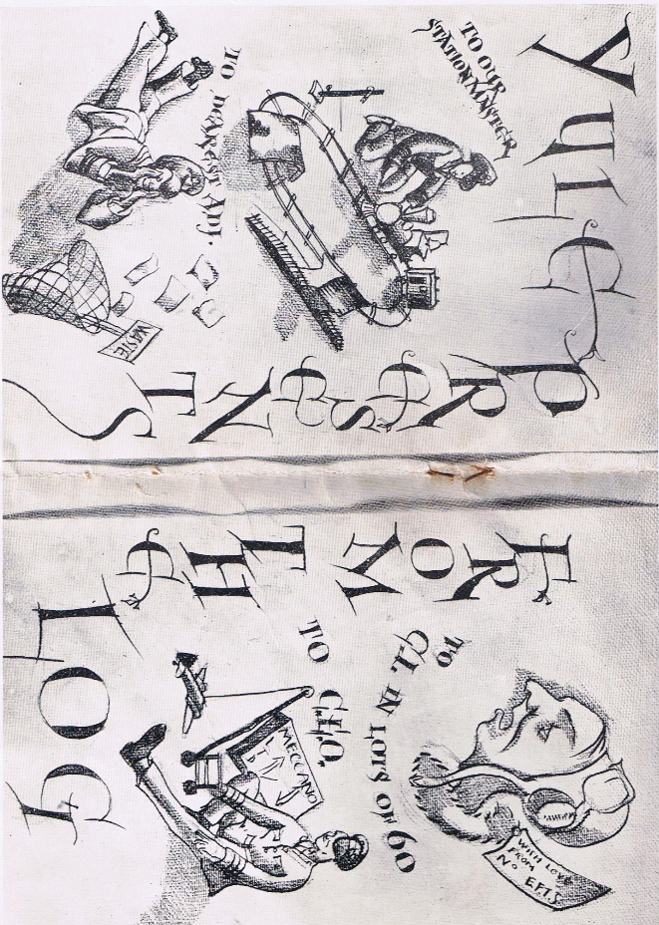
The weather may be hot, yet the Christmas dinner is still built up round the traditional turkey and plum pudding. Toasts are drunk and ‘Crackers’ are pulled, and everyone ends up wearing a paper hat. Some items on the dinner table would look strange to an Englishman, such as watermelon, for instance, but in general it seems that Christmas dinner is the same the whole world over. It is the occasion, too, when the Australian brings out the best of his fine local wines.
This year will be very much of a wartime Christmas for the Australians, with many sons and husbands serving in all parts of the world. Christmas is ideally a family affair, but though we are all far from home, we shall all remember with pleasure the year that the fortunes of war brought British and Australians together to sit down to turkey and plum pudding in Canada.”
Figure Legend: Station master was RAF slang for Commanding Officer; the ‘Dearest Adj.’ was the adjunct, administrative assistant to the Commanding Officer; G.I.–Ground Instructor, classes consisted of 60 students each; G.L.O.–Ground Liaison Officer.
Half of the personnel on the base went on Christmas furlough on December 23. In 1942 the furlough was for five days. No mention is made in the 1943 Daily Log about how long furlough was in 1943 but it was likely for five days as well. If the routine of 1942 was followed the other half of the personnel would have gone on a five-day furlough on December 30.
For those who stayed on the base the Christmas meal was an important event. The airmen’s meal was served by the commissioned and non-commissioned officers. Below is a partial account from the Penhold Log of the Christmas meal.
“Christmas Dinner
MENU
Cream of Tomato Soup
Fried Fillets of Cod Tartar Sauce
Roast Turkey Sage and Onion Dressing Giblet Gravy Cranberry Sauce
Roast Potatoes Creamed Potatoes Brussels Sprouts Green Peas
Lettuce and Celery Hearts Dinner Rolls
Christmas Pudding and Brandy Sauce Mincemeat Tarts
Cheese Biscuits Mixed Pickles
Apples Grapes Oranges
Cigarettes Beer Minerals
A great deal of work spread over many weeks has gone towards the collection and preparation of the items on this ‘carte’.
When multiplied by the number of men who will sit down to diner, this menu means bags of food. The Supply Depot have nobly rounded up eighty turkeys to be roasted in the kitchen stoves, and the cooks are busy preparing piles of stuffing ̶ small item which accounts for no less than 20 loaves of bread. Vegetables add up to a big item ̶ eight sacks of potatoes to peel, and 300 pounds of Brussels sprouts to be cleaned and trimmed, all by hand. The chaps detailed to prepare the vegetables need a very lively and kindly Christmas spirit to face up cheerfully to such a job.
Traditional Christmas puddings were long ago cooked and tied up in their neat pudding bags. There will be 150 pounds of pudding, containing 100 pounds of raisins, sultanas and currants, together with a secret amount of brandy. L.A.C. Austin was the presiding genius in making the Christmas puddings. After they had been mixed there was 18 hours of careful tending while they were steamed.
At one time it seemed that there would be no mincemeat tarts, for when the Messing Officer went to Calgary early in November to purchase Christmas supplies, mincemeat was very hard to come by. By visiting all the wholesale houses and buying in piece lots it was possible to obtain the fruit for the puddings and the cake. When the mincemeat was requested, most of the dealers just laughed. However, one kindly gentleman, on being told the heart-rendering story of the chaps at Penhold who were going to have to go without mince pie at Christmas, quickly got on the telephone and, by a spot of smart scrounging, contrived to raise a supply of mincemeat.
Then there is the cake . . . a monster with an iced top measuring six feet by four feet. The icers have been busy designing a plan of the camp to go on top of the cake in sugar and other decoration ̶-so maybe you will end up by eating a slice of your own billet. L.A.C. Austin also made the cake, and the idea for the design came from F/Sgt. Moore, who did a similar job at Estevan last Christmas.
The Mess Hall will hardly look like home, but it will have a festive appearance, with its decorations and, true to an old R.A.F. custom, the men will sit at their seats and be waited on by their own officers and N.C.O.s.
P.S. ̶ So don’t annoy Chiefy just before Christmas or he might, quite innocently, forget to collect your plate of turkey.”

A.F.C. is Air Force Cross awarded for ‘acts of valour, courage or devotion to duty’
A reference to the Station, No. 36 SFTS
Perhaps a little dig at the CO’s A.F.C.
Likely 100 pounds each
Non Commissioned Officers

